CSE 581

**Lab 8: Selects with Data Types**

***Please note these are my solutions. In some cases you could have done things differently and still be correct. Please look at the comments and images for more information/guidance.***

**Steps:**

*Do this lab against the Northwind database. Be cognizant of data types please.*

1. Select all data from the Orders table, ordered by OrderDate, newest date on top, for orders shipped between January 1997 and August 1997.

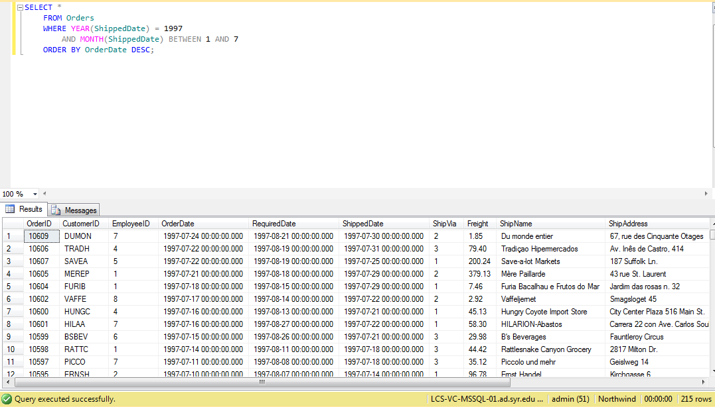

1. Select all data from the Orders table, ordered by OrderDate, newest date on top, for orders placed between July 1996 and January 1997.

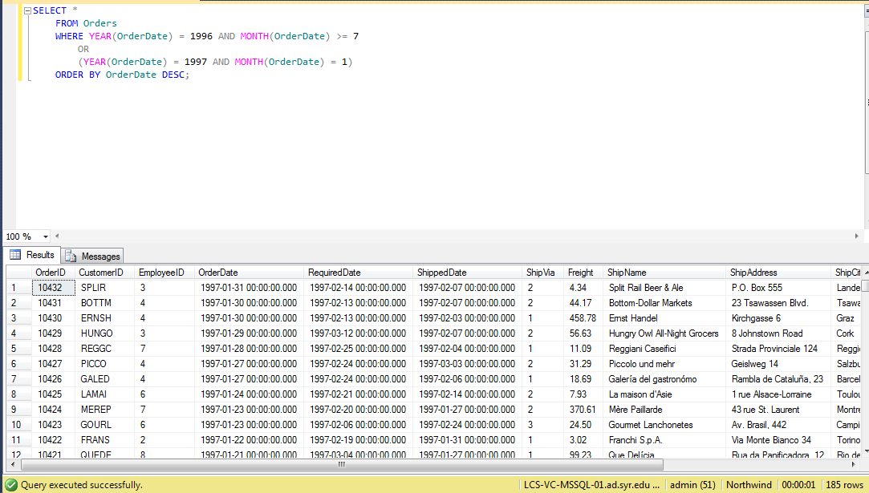

1. Select all data from the Orders table, for orders placed in January 1998.

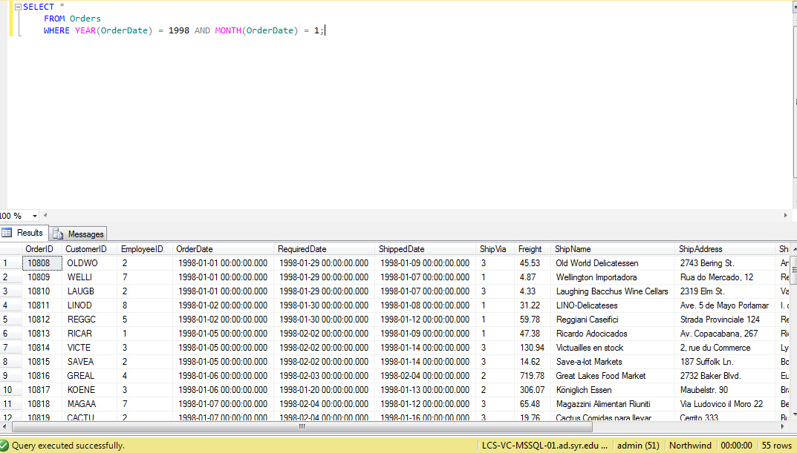

1. Select count of Orders shipped in 1996, 1997 and 1998. (one query containing all values) -> 2 columns (count and year), 3 rows (1 row per year)

